Nutritional needs will vary depending on position, but athletes need consistency and balance. The macronutrients essential for the body are:
- Carbohydrates: Carbohydrates are the go-to source of energy for intermittent sports, like football, where glycogen stores are often depleted during workouts and training.
RECOMMEND
  - Whole Grains: oatmeal, 100% whole wheat bread, whole wheat or corn tortillas, whole wheat pasta, brown rice, and low sugar cereals containing at least 5g of protein per serving
  - Fruit: fresh whole fruit including apples, pears, bananas, melon, pineapple, cantaloupe
  - Non-starchy Vegetables: broccoli, spinach, peppers, zucchini, lettuce greens (the darker the better), squash, onions, cauliflower, mushrooms, tomatoes, carrots
  - Starchy Vegetables: potatoes, sweet potatoes, peas, corn, butternut squash
  - Beans and legumes: kidney beans, black beans, white beans, lentils
  - Dairy: Greek yogurt, low-fat milk and chocolate milk
AVOID
  - Refined carbohydrates including white bread, cakes, candy, cookies, pies, high sugar cereals, sodas, and juices

- Protein: Players need enough protein to build muscle, and also to repair muscle damage that occurs during training.
RECOMMEND
  - Skinless chicken or turkey, lean red meats, beans, eggs and fish.

AVOID
  - Excessive protein: excessive amounts of protein offer no benefit to stimulating muscle growth, and will more often just displace other important nutrients your body needs.

- Fat
RECOMMEND
  - Monounsaturated Fats: Olives and olive oil, canola oil, avocado, nuts (pistachios, macadamia, almonds, cashews) and sunflower seeds
  - Omega-3 Fatty Acids (polyunsaturated fats): fatty fish (salmon, tuna, halibut, trout), walnuts, flax and chia seeds

AVOID
  - Full fat dairy, butter, palm oil, fried foods, fatty cuts of beef, pork and chicken, fried foods, margarine, very creamy foods (i.e., salad dressings and mayonnaise) and anything made with partially hydrogenated oil

Creating a meal plan for young athletes
Athletes can create and track meal planning using resources accessible through MyPlate.gov. The below example was created by inputting the athlete’s age, height, weight and activity level.
EXAMPLE:
Your MyPlate Plan: 3200 Calories, Age 14+ Years, 5’7”, 150 lbs
Below are the daily recommended amounts for each food group.
Click on the food group buttons to learn more and get started.
Download your MyPlate Plan.
Talk with your health care provider about an eating pattern and physical activity program that is right for you.
Back to MyPlate Plan
Fruit - 2½ cups
1 cup from the Fruit Group counts as:
- 1 cup raw, frozen, or cooked/canned fruit; or
- ½ cup dried fruit; or
- 1 cup 100% fruit juice
Read more
Vegetables - 4 cups
1 cup from the Vegetable Group counts as:
- 1 cup raw or cooked/canned vegetables; or
- 2 cups leafy salad greens; or
- 1 cup 100% vegetable juice
Read more
Grains - 10 ounces
1 ounce from the Grains Group counts as:
- 1 slice bread; or
- 1 ounce ready-to-eat cereal; or
- ½ cup cooked rice, pasta, or cereal
Read more
Protein - 7 ounces
1 ounce from the Protein Foods Group counts as:
- 1 ounce seafood, lean meat, or poultry; or
- 1 egg; or
- 1 Tbsp peanut butter; or
- ¼ cup cooked beans, peas, or lentils; or
Read more
Dairy - 3 cups
1 cup from the Dairy Group counts as:
- 1 cup dairy milk or yogurt; or
- 1 cup lactose-free dairy milk or yogurt; or
- 1 cup fortified soy milk or yogurt; or
- 1½ ounces hard cheese
Read more

Fueling your adolescent athlete
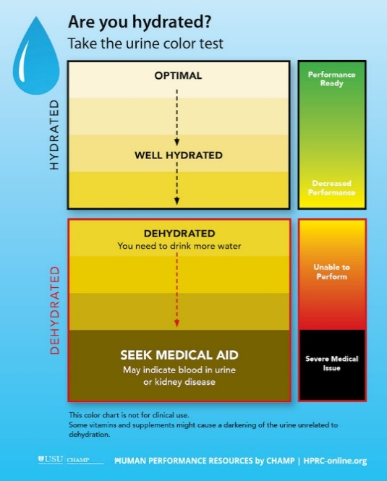
Knowing what and when to eat and drink can help your young athlete be on top of his or her game. Your teen’s schedule might seem more like a pro athlete’s workout schedule with two-a-days, strength-training programs, and speed training. However, these are common building blocks of teen athletes’ training for sports. The table below provides general guidelines for what and when to drink and eat before, during, and after practice and workouts.
Fluids | Divide your child’s weight (in pounds) by two—that’s the minimum amount of water (in ounces) he or she should drink over an entire day. One ounce is about a gulp.
Before exercise | - Breakfast: water and/or 100% fruit juice  - Before exercise: water (5–10 oz 15–20 min before)  - Check bodyweight before workout
During exercise | - First hour: water (5–10 oz every 15–20 min)  - Longer than one hour: sports beverage (3–8 oz every 15–20 min)
After exercise | - Check your child’s bodyweight again and compare it with his or her pre-workout weight. Hydrate enough to make up for the weight lost.  - Check your child’s urine color. (Use a color chart like the one below for an idea what to look for.)  - Within two hours after exercise: water or sports beverage (20–24 oz per pound lost).

Staying hydrated goes hand in hand with peak performance. It’s often difficult for adolescent athletes to stay hydrated in heat and humidity, but drinking regularly and keeping an eye on urine color can be helpful.

Eating nutrient-packed meals and snacks before, after, and even during practices and games is essential for optimal performance. The right balance of carbohydrates and protein work together to fuel and build muscles. The table below offers some ideas.
Before exercise | During exercise | After exercise
Essential: Get some food in your system before practice or workout! (Aim for 30–60 minutes before.)  Eat what you can tolerate, such as:  - Breakfast sandwich (egg with whole-grain English muffin or bagel)  - Whole-grain bread/bagel with peanut butter or low-fat cream cheese  - Greek yogurt with granola  - Whole-grain cereal, low-fat milk, and fresh fruit  - Oatmeal with fruit  - Smoothie made with low-fat yogurt and fruit (fresh or frozen)  - Granola bar (look for at least 4 grams of protein and 3 grams | Break (for Two-a-Days): Eat what you can tolerate and remember that you need to replenish for your second workout.  Suggestions:  - Whole-grain bread with lean meat  - PBJ sandwich  - Hummus with pita chips  - Whole-grain crackers with low-fat cheese  - Granola bar and fresh fruit  - Add pretzels or baked chips  - Add low-fiber fresh fruit such as oranges or watermelon | Essential: Eat immediately after your workout (gym lobby or ride home)—within about 45 minutes.  Suggestions:  - Low-fat chocolate milk (one or two 8 oz servings)  - Low-fat yogurt with fruit  - Trail mix  - Turkey wrap  - PBJ sandwich  Dinner: Replenish the body with a well-balanced nutritious meal and hydrate with water.

RESOURCES
Teens | MyPlate
Fueling your adolescent athlete | HPRC (hprc-online.org)

